ASSIGNMENT-2
1.

class turn{
private prevNo = Symbol();
private currNo = Symbol();
constructor(){
this.prevNo = 0;
this.currNo = 1;
}
next(){
let curr = Symbol();
curr = this.prevNo + this.currNo;
this.prevNo = this.currNo;
this.currNo = curr;

return {
current : curr,
next : this.prevNo + this.currNo
}
}
}

let t = new turn();
console.log(t.next());
console.log(t.next());
console.log(t.next());
console.log(t.next());
console.log(t.next());

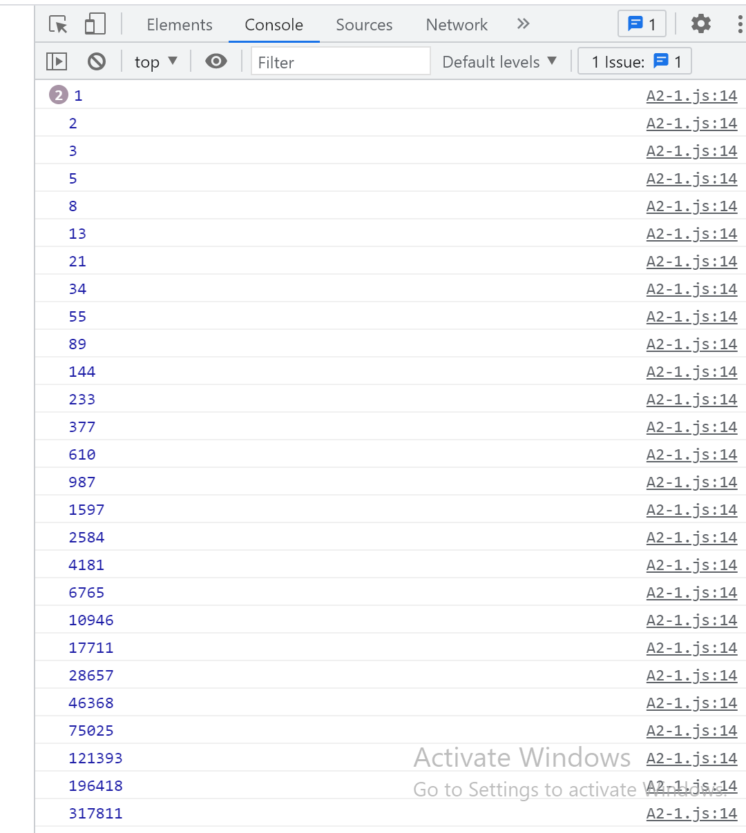

2.
// we can push arms nos into a list and then use this
// here i have taken predfined list with numbers
const listArm=[0,1,2,3,4,5,6,7,8,9,153,370,371];
const iterator = listArm[Symbol.iterator]();
function getNextArmstrong(){

return {
"next value" : iterator.next().value
}
}
console.log(getNextArmstrong());
console.log(getNextArmstrong());
console.log(getNextArmstrong());
console.log(getNextArmstrong());
console.log(getNextArmstrong());
console.log(getNextArmstrong());

3.
// we can push arms nos into a list and then use this
// here i have taken predfined list with numbers
const listArm = [3,4,5,6,7,8,9,153,370,371,407,1634,8208,9474];
const iterator = listArm[Symbol.iterator]();
function getnext(){

return iterator.next().value;
}
// generator
function* arms() {
let current = 1;
let next = 2;
while (true) {
let reset = yield current;
[current, next] = [next, getnext(next)];
if (reset) {
current = 1;
next = 2;
// arms();
}
}
}

const s = arms();
console.log(s.next().value); // 1
console.log(s.next().value); // 2
console.log(s.next().value); // ...
console.log(s.next().value);
console.log(s.next().value);
console.log(s.next().value);
console.log(s.next().value);
console.log(s.next().value);
console.log(s.next().value); // 9

// should return next ARMSTRONGs
console.log(s.next().value);
console.log(s.next().value);
console.log(s.next().value);
console.log(s.next().value);
console.log(s.next().value);
console.log(s.next().value);
console.log(s.next().value);

// reset generator
console.log(s.next(true).value);

console.log(s.next().value); // 1
console.log(s.next().value); // 2

